**727721EUIT137**

**Question -1**

package com.test.test;

import org.openqa.selenium.By;

import org.openqa.selenium.WebDriver;

import org.openqa.selenium.chrome.ChromeDriver;

import org.openqa.selenium.chrome.ChromeOptions;

import io.github.bonigarcia.wdm.WebDriverManager;

public class Q1 {

public static void main(String[] args) throws InterruptedException {

// TODO Auto-generated method stub

ChromeOptions co=new ChromeOptions();

co.addArguments ("--remote-allow-origins=*");

WebDriverManager.chromedriver().setup ();

WebDriver driver=new ChromeDriver(co);

driver.get ("https://www.amazon.in/CELLBELL%C2%AE-Extended-Workspace-Multipurpose-Footrest/dp/B0BV6VWJK2/ref=sr_1_1_sspa?keywords=table&qid=1681288230&sr=8-1-spons&sp_csd=d2lkZ2V0TmFtZT1zcF9hdGY&th=1");

driver.manage().window().maximize() ;

String currentTitle=driver.getTitle();

System.out.println(currentTitle);

String expectedTitle="CELLBELL® Pro Extended Workspace Table Mat Finish Top, Steel Frame, Multipurpose Laptop Table with Footrest (Pro Footrest Brown) : Amazon.in: Computers & Accessories";

if(currentTitle.equals(expectedTitle)) {

System.out.println("Title Matched!");

}

else {

System.out.println("Title not Matched!!");

}

driver.findElement(By.xpath("//*[@id=\"add-to-cart-button\"]")).click();

driver.findElement(By.xpath("//*[@id=\"nav-cart\"]")).click();

driver.findElement(By.xpath("//*[@id=\"a-autoid-0-announce\"]")).click();

driver.findElement(By.xpath("//*[@id=\"quantity_5\"]")).click();

driver.findElement(By.xpath("//*[@id=\"sc-buy-box-ptc-button\"]/span/input")).click();

}

}

**Output:**

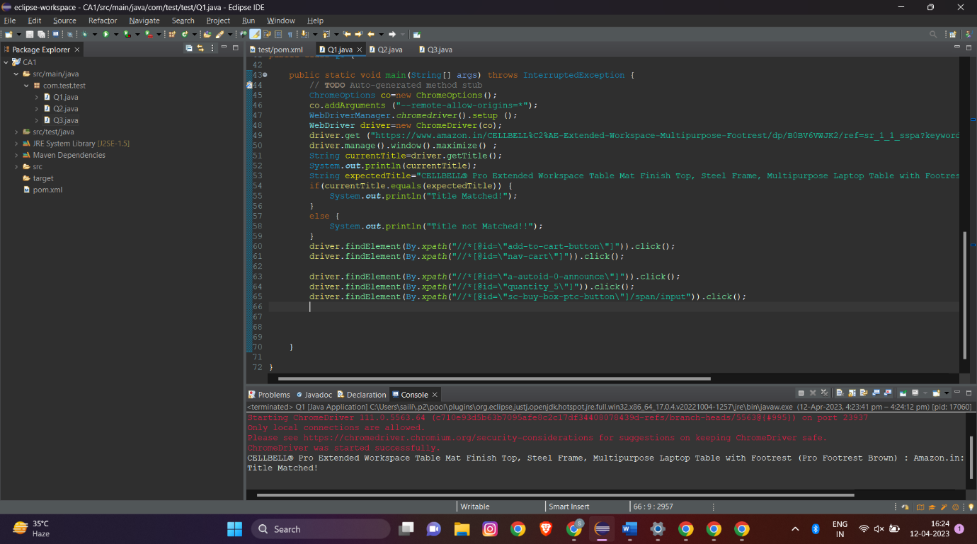

**Question -2**

package com.test.test;

import org.openqa.selenium.By;

import org.openqa.selenium.JavascriptExecutor;

import org.openqa.selenium.WebDriver;

import org.openqa.selenium.chrome.ChromeDriver;

import org.openqa.selenium.chrome.ChromeOptions;

import io.github.bonigarcia.wdm.WebDriverManager;

public class Q2 {

public static void main(String[] args) {

// TODO Auto-generated method stub

ChromeOptions co=new ChromeOptions();

co.addArguments ("--remote-allow-origins=*");

WebDriverManager.chromedriver().setup ();

WebDriver driver=new ChromeDriver(co);

driver.get ("https://www.amazon.in/");

driver.manage().window().maximize() ;

String currentTitle=driver.getTitle();

System.out.println(currentTitle);

String expectedTitle="Online Shopping site in India: Shop Online for Mobiles, Books, Watches, Shoes and More - Amazon.in";

if(currentTitle.equals(expectedTitle)) {

System.out.println("Title Matched!");

}

else {

System.out.println("Title not Matched!!");

}

driver.findElement(By.xpath("//*[@id=\"twotabsearchtextbox\"]")).sendKeys("iphone");

driver.findElement(By.xpath("//*[@id=\"nav-search-submit-button\"]")).click();

JavascriptExecutor j=(JavascriptExecutor) driver;

j.executeScript("window.scrollBy(0,300)","");

String currentdetail=driver.findElement(By.xpath("//*[@id=\"search\"]/div[1]/div[1]/div/span[1]/div[1]/div[3]/div/div/div/div/div/div/div/div[2]/div/div/div[1]/h2/a/span")).getText();

String ExxpectedDetail="Apple iPhone 12 (64GB) - (Product) RED";

if(currentdetail.equals(ExxpectedDetail))

{

System.out.print("Details Matched");

}

else

{

System.out.print("Details Not Matched");

}

String detail1=driver.findElement(By.xpath("//*[@id=\"search\"]/div[1]/div[1]/div/span[1]/div[1]/div[3]/div/div/div/div/div/div/div/div[2]/div/div/div[1]/h2/a/span")).getText();

System.out.println(detail1);

String detail2=driver.findElement(By.xpath("//*[@id=\"search\"]/div[1]/div[1]/div/span[1]/div[1]/div[3]/div/div/div/div/div/div/div/div[2]/div/div/div[1]/h2/a/span")).getText();

System.out.println(detail2);

String detail3=driver.findElement(By.xpath("//*[@id=\"search\"]/div[1]/div[1]/div/span[1]/div[1]/div[3]/div/div/div/div/div/div/div/div[2]/div/div/div[1]/h2/a/span")).getText();

System.out.println(detail3);

String detail4=driver.findElement(By.xpath("//*[@id=\"search\"]/div[1]/div[1]/div/span[1]/div[1]/div[3]/div/div/div/div/div/div/div/div[2]/div/div/div[1]/h2/a/span")).getText();

System.out.println(detail4);

String detail5=driver.findElement(By.xpath("//*[@id=\"search\"]/div[1]/div[1]/div/span[1]/div[1]/div[3]/div/div/div/div/div/div/div/div[2]/div/div/div[1]/h2/a/span")).getText();

System.out.println(detail5);

driver.findElement(By.xpath("//*[@id=\"p_36/7252032031\"]/span/a/span")).click();

driver.findElement(By.xpath("//*[@id=\"p_n_pattern_browse-bin/1464446031\"]/span/a/span")).click();

}

}

**Output:**

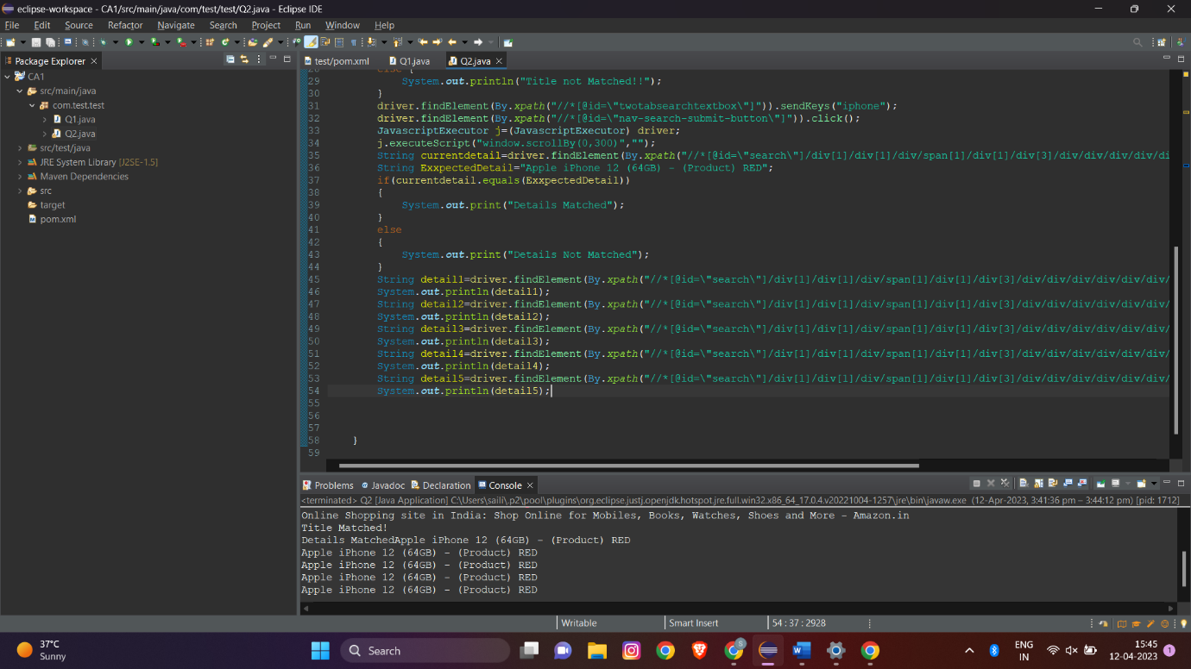

**Question -3**

package com.test.test;

import org.openqa.selenium.By;

import org.openqa.selenium.WebDriver;

import org.openqa.selenium.WebElement;

import org.openqa.selenium.chrome.ChromeDriver;

import org.openqa.selenium.chrome.ChromeOptions;

import io.github.bonigarcia.wdm.WebDriverManager;

public class Q3 {

public static void main(String[] args) throws InterruptedException {

// TODO Auto-generated method stub

ChromeOptions co=new ChromeOptions();

co.addArguments ("--remote-allow-origins=*");

WebDriverManager.chromedriver().setup ();

WebDriver driver=new ChromeDriver(co);

driver.manage().window().maximize();

driver.get("https://www.amazon.in/");

String currenttitle = driver.getTitle();

String expectedtitle = "Online Shopping site in India: Shop Online for Mobiles, Books, Watches, Shoes and More - Amazon.in";

System.out.println(expectedtitle);

if(currenttitle.equals(expectedtitle)) {

System.out.println("Title Matched!");

}

else {

System.out.println("Title Mismatched!");

}

driver.findElement(By.xpath("//*[@id=\"nav-link-accountList\"]")).click();

WebElement txtBoxl=driver.findElement(By.xpath("//*[@id=\"ap_email\"]"));

txtBoxl.sendKeys("1234567890");

driver.findElement(By.xpath("//*[@id=\"continue\"]")).click();

WebElement txtBox2=driver.findElement(By.xpath("//*[@id=\"ap_password\"]"));

txtBox2.sendKeys("abc123");

driver.findElement(By.xpath("//*[@id=\"signInSubmit\"]")).click();

driver.findElement(By.xpath("//*[@id=\"nav-link-accountList\"]")).click();

driver.findElement(By.xpath("//*[@id=\"a-page\"]/div[2]/div/div[2]/div[1]/a/div/div")).click();

String yourorder=driver.findElement(By.xpath("//*[@id=\"a-page\"]/section/div[1]/div[4]/form/label")).getText();

System.out.println(yourorder);

}

}

**Output:**

